Subject: Economics, Business Management | Class: 10, 11, 12
Date: _________________________ | Teacher: _____________________
Theme: Microeconomics
Learning Objective(s): By the end of the lesson the students will be able to do:
- Accurately identify and apply basic microeconomic terms to real life business section
- Properly assess a barbershop/salon using key terms and concepts
Keywords/Concepts: microeconomics, (dis)economies of scale, bulk buying, micromanage, marginal revenue, externality, external cost, product differentiation, non-price competition;
Starter Activity (5 mins.):
- Writing/Discussion: How was your last visit to the salon/barbershop”?
- Were you fully satisfied? Why or why not?
Plan of Activities:  - Write, review, and interact with new vocabulary  - Create groups of 2-4 students for reviewing the show  - Teacher will introduce and show “Tabatha’s Salon Makeover” before Tabatha gives her review  - While viewing the show, students will write notes on the condition of the restaurant applying new vocabulary (place on poster board using a bubble map)  - At the end of the viewing, students will discuss similar review notes  - Teacher will show Tabatha’s criticism of the salon  - Students will compare/contrast and critique Tabitha’s review (Venn Diagram is optional) |  | Resources/Teacher’s Aids  - Video player  - Worksheets  - Poster board  - Multi-colored markers
Differentiated main learning activity (15 mins.):

Group 1: Teacher will make cutout pictures (from screenshots of the show) and correlating terms for students to practice terms.

Group 2: Create pre-made bubble maps with hints for lower level students

Assessment
- Option 1: Students will create a model diagram (digital or physical) of an ideal barbershop/salon and write a rationale behind how they can optimize productivity.
- Option 2: Students will visit salons and take pictures (for a slideshow) of salons that follow best microeconomic practices.
- Option 3: Students will make a plan of how they will creatively show their knowledge and skills
Reflection:
- Written paragraph to review the terms and their applications to real-world situations.
- Written paragraph about a hypothetical visit to a restaurant as a business consultant (and apply terms to the situation).

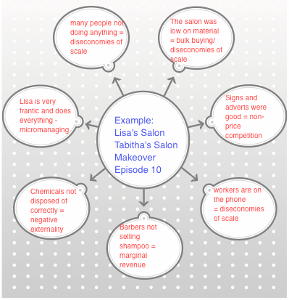
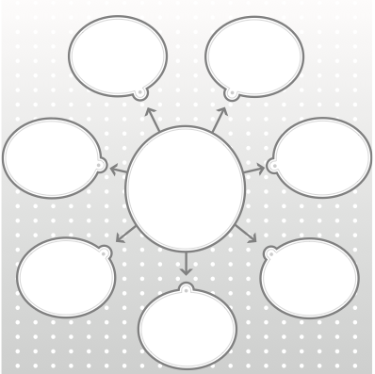
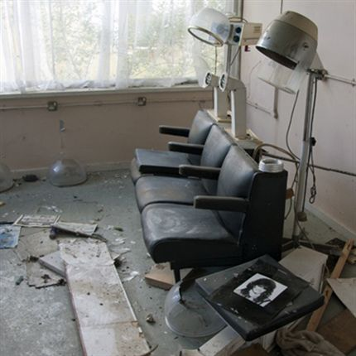
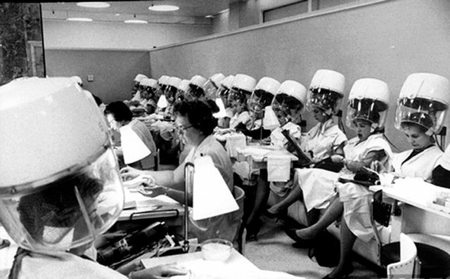

NON-PRICE COMPETITION
ECONOMIES OF SCALE
DISECONOMIES OF SCALE

